Level 1 🚨
✅1. SOLID Principle
S — Single Responsibility Principle (SRP)
One class = one job.
A class should have only one reason to change.
One Class should do only one thing at a time.
📦 Real-life: A delivery boy only delivers parcels — he doesn’t also bake the cake.

O — Open/Closed Principle (OCP)
Open for extension, closed for modification.
Add new functionality without changing existing code.
It means we should able to extends a class behaviour without modifying it.
📦 Real-life: You can add new cake Flavors without changing the oven.

L — Liskov Substitution Principle (LSP)
Child classes should work wherever the parent works without breaking logic.
Child should replace parent without issues
📦 Real-life: Any delivery boy (bike or scooter) can deliver cake — it still works

I — Interface Segregation Principle (ISP)
Don’t force classes to implement unused methods.
Don’t force to do what’s not needed
📦 Real-life: A baker doesn’t need to know how to ride a scooter, and a delivery boy doesn’t need to know baking.

D — Dependency Inversion Principle (DIP)
Depend on abstraction, not on concrete classes.
Depend on interfaces, not concrete classes
📦 Real-life: A bakery hires any delivery service — bike, scooter, or car — without changing its code.

✅2. Sorting algorithms in Java
1. Bubble Sort — Compare and swap neighbors until sorted
2. Selection Sort — Find the smallest and place it in the correct position
3. Insertion Sort — Take one item at a time and insert it into its correct position
4. Quick Sort — Using Java’s Built-in Sort (Quicksort under the hood - Arrays. Sort ())
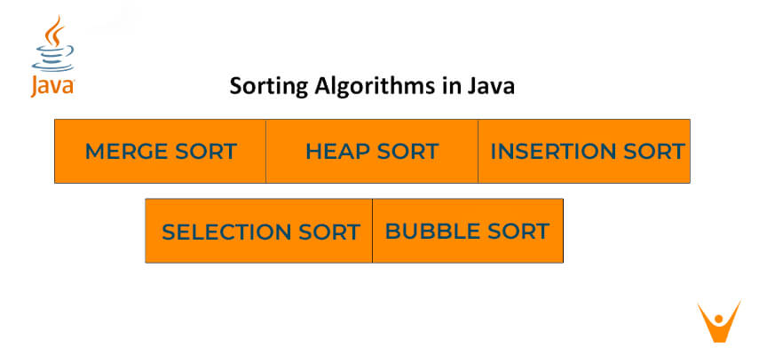
✅3. Authentication vs Authorization
Authentication: Verifying your identity when you log in.
Authorization: Deciding if you can access the admin panel after logging in.

✅4. Agile Methodology
Agile is a flexible way of working where you plan small, build small, check quickly, and improve continuously instead of making one big plan for the whole project.

How Agile Works (Steps)
- Backlog → List of all things to do (like a wedding checklist)
- Sprint Planning → Pick what to do in the next 2 weeks
- Daily Stand-up → Short daily meeting (“What did I do? What’s next? Any problems?”)
- Review → Show what’s done & get feedback
- Retrospective → Discuss what went well and what to improve for next sprint

Easy Memory Tip:
Agile = Plan small → Build small → Check → Improve → Repeat
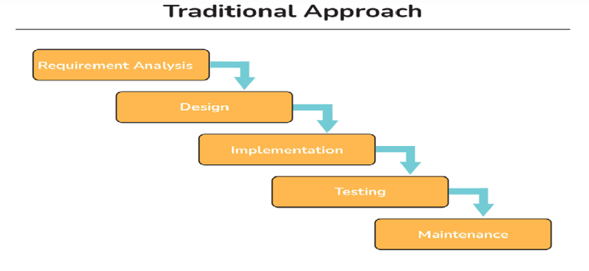
✅5. Azure DevOps Cloud
It’s Microsoft’s online platform that helps teams plan, build, test, and deliver software — all from the cloud.
Key Features (in Cloud)
- Azure Boards → Plan & track work (digital task board)
- Azure Repos → Store and manage your code (like GitHub, but inside Azure)
- Azure Pipelines → Automatically build & deploy apps
- Azure Test Plans → Test your app to find issues early
- Azure Artifacts → Store reusable code packages

Why It’s Great for Beginners
- No heavy setup — just log in and work.
- Everything in one place (planning, coding, testing, deploying).
- Perfect for remote teams.
- Saves time with automation.

1️⃣ What is Azure DevOps and why is it used?
Answer:
Azure DevOps is Microsoft’s cloud-based platform that helps teams plan, develop, test, and deliver software faster.
It’s used because it provides everything in one place — task tracking (Azure Boards), code storage (Azure Repos), automation (Azure Pipelines), testing (Azure Test Plans), and package management (Azure Artifacts).
It makes teamwork easier, automates work, and speeds up delivery.

2️⃣ What is CI/CD in Azure DevOps?
Answer:
- CI (Continuous Integration) → Every time a developer pushes code, Azure Pipelines automatically builds and tests it to detect errors early.
- CD (Continuous Delivery/Deployment) → After passing tests, the code is automatically deployed to servers or cloud environments.
💡 In short: CI = Build & Test, CD = Deliver & Deploy — both are automated.

3️⃣ Difference between Azure Repos and Azure Pipelines
Answer:
- Azure Repos → Stores and manages source code with version control (Git or TFVC).
- Azure Pipelines → Automates building, testing, and deploying that code.
💡 Think: Repos = Where code lives, Pipelines = How code is delivered.

✅6. What is JUnit Testing?
JUnit is a Java framework used to test small parts of your code (units) to make sure they work correctly.
It’s like double-checking your work automatically every time you make changes.

JUnit = "Automatic Code Checker" → Write once, run anytime to see if your code still works.

step-by-step how to test Java code using JUnit
1. Prerequisites
- Java JDK installed
- Build tool or IDE (IntelliJ/Eclipse, Maven or Gradle)
- Add JUnit 5 (Jupiter) as a test dependency (example below)

2. Step-by-step: Write and run your first tests
Step 1 — Identify the unit to test
Pick a small, focused class or method (e.g., Calculator.add ()).
Step 2 — Create test class
Use the naming convention: ClassNameTest (placed under src/test/java/...).
Step 3 — Write simple tests using AAA (Arrange, Act, Assert)
Arrange set up inputs, Act call the method, Assert check the result.
Calculator code:
java
// src/main/java/myapp/Calculator.java
package myapp;

public class Calculator {
public int add (int a, int b) {return a + b;}
public int divide (int a, int b) {
if (b == 0) throw new IllegalArgumentException ("Cannot divide by zero");
return a / b;
}
}
JUnit test:
java
// src/test/java/myapp/CalculatorTest.java
package myapp;

import org.junit.jupiter.api. *;
import static org.junit.jupiter.api. Assertions. *;

class CalculatorTest {

Calculator calc;

@BeforeEach
void setUp () {
calc = new Calculator (); // Arrange
}

@Test
void testAdd () { // Act + Assert
assertEquals (5, calc.add (2, 3));
}

@Test
void testDivide () {
assertEquals (2, calc. divide (6, 3));
}

@Test
void testDivideByZero () {
assertThrows (IllegalArgumentException.class, () -> calc. divide (5, 0));
}
}
Step 4 — Run tests
- In IntelliJ/Eclipse: right-click test class → Run.
- Maven: mvn test
- Gradle: /gradlew test
Green = pass. Red = failure → read stack trace, fix code or test, re-run.

1️⃣What is the difference between @Before, @BeforeClass, @After, and @AfterClass in JUnit?
Answer in short:
- @Before → Runs before each test method. (e.g., resetting test data before every test)
- @After → Runs after each test method. (e.g., cleanup after test)
- @BeforeClass → Runs only once before all tests in the class. (e.g., DB connection setup)
- @AfterClass → Runs only once after all tests in the class. (e.g., closing DB connection)

2️⃣ How do you write a JUnit test case?
Answer in short:
- Create a test class
- Annotate test methods with @Test
- Use assertions like assertEquals, assertTrue, etc. to validate results
Example:
@Test
public void testSum () {
assertEquals (5, Calculator.add (2, 3));
}

3️⃣ What is the difference between assertEquals () and assertSame ()?
Answer in short:
- assertEquals () → Compares values (checks if contents are equal)
- assertSame () → Compares references (checks if both point to the same object in memory)

✅7. What is Bean Life Cycle?
In Spring Framework, a bean is simply an object that Spring manages for you.
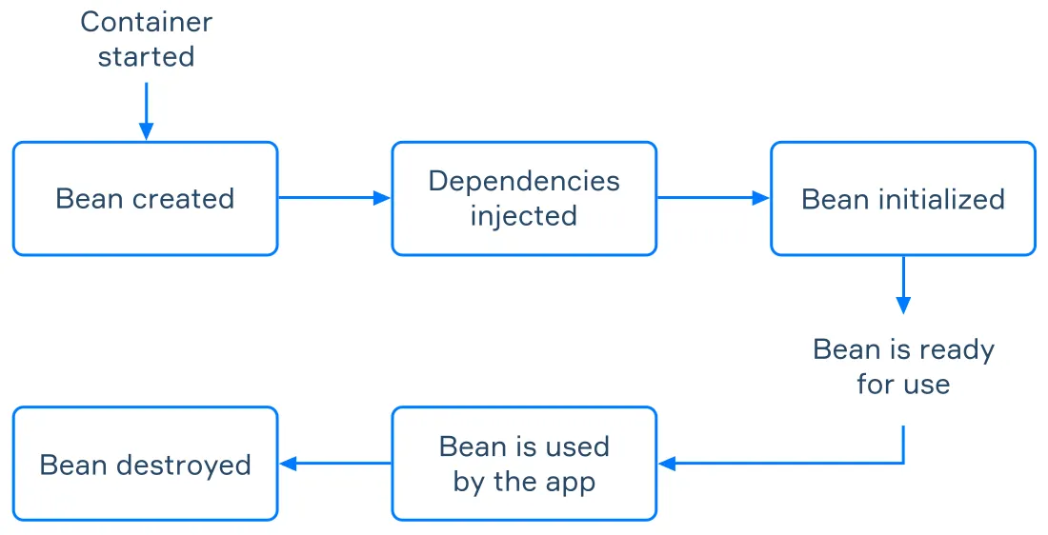

1️⃣ Can you explain the Spring Bean Life Cycle in simple steps?
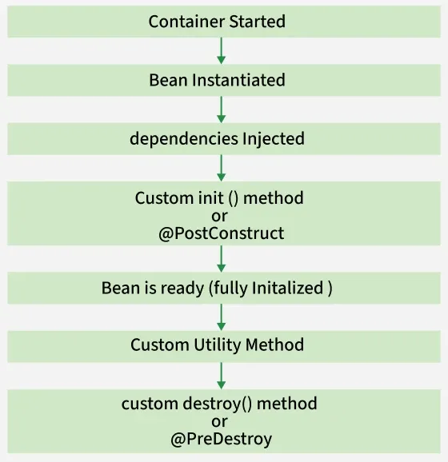

2️⃣ Difference between @PostConstruct and InitializingBean.afterPropertiesSet()?
Expected Answer:
- Both are used to run code after bean properties are set.
- @PostConstruct → Annotation-based, preferred for readability, works with any POJO.
- afterPropertiesSet() → From InitializingBean interface (requires implementing it).
- In modern Spring, @PostConstruct is preferred.

3️⃣ How do you define custom init () and destroy () methods for a bean?
Expected Answer:
- Using XML:xml
<bean id="myBean" class="com.example.MyBean" init-method="init" destroy-method="cleanup"/>
- Using Java Config:java
@Bean (initMethod = "init", destroyMethod = "cleanup")
public MyBean myBean () {
return new MyBean ();
}
- Or by annotations:
java
@PostConstruct
public void init () {}

@PreDestroy
public void cleanup () {}

Level 2 🗂
✅8. JWT Authentication
JWT (JSON Web Token) authentication is a way to securely transmit user identity between the client and server after login, without storing session data on the server.

Here’s JWT authentication in simple steps
1️⃣ Login → User sends username + password to the server.
2️⃣ Verify → Server checks credentials.
3️⃣ Create Token → If correct, server makes a JWT (with user info) and signs it with a secret key.
4️⃣ Send Token → Server gives token to user → user stores it (localStorage / sessionStorage / cookie).
5️⃣ Access API → User sends token in Authorization: Bearer <token>.
6️⃣ Validate → Server checks token’s signature + expiry →
✅ If valid → process request.
❌ If invalid/expired → 401 Unauthorized.

💡 Memory Tip (Think "LVCSVV")
- Login → Verify → Create Token → Send Token → Visit API → Validate Token

Even Shorter – Movie Ticket Emoji Analogy 🎟
🎟 Get Ticket (login) → 🚪 Show Ticket (send token) → 🛂 Check Ticket (validate) → 🎬 Watch Movie (access API)

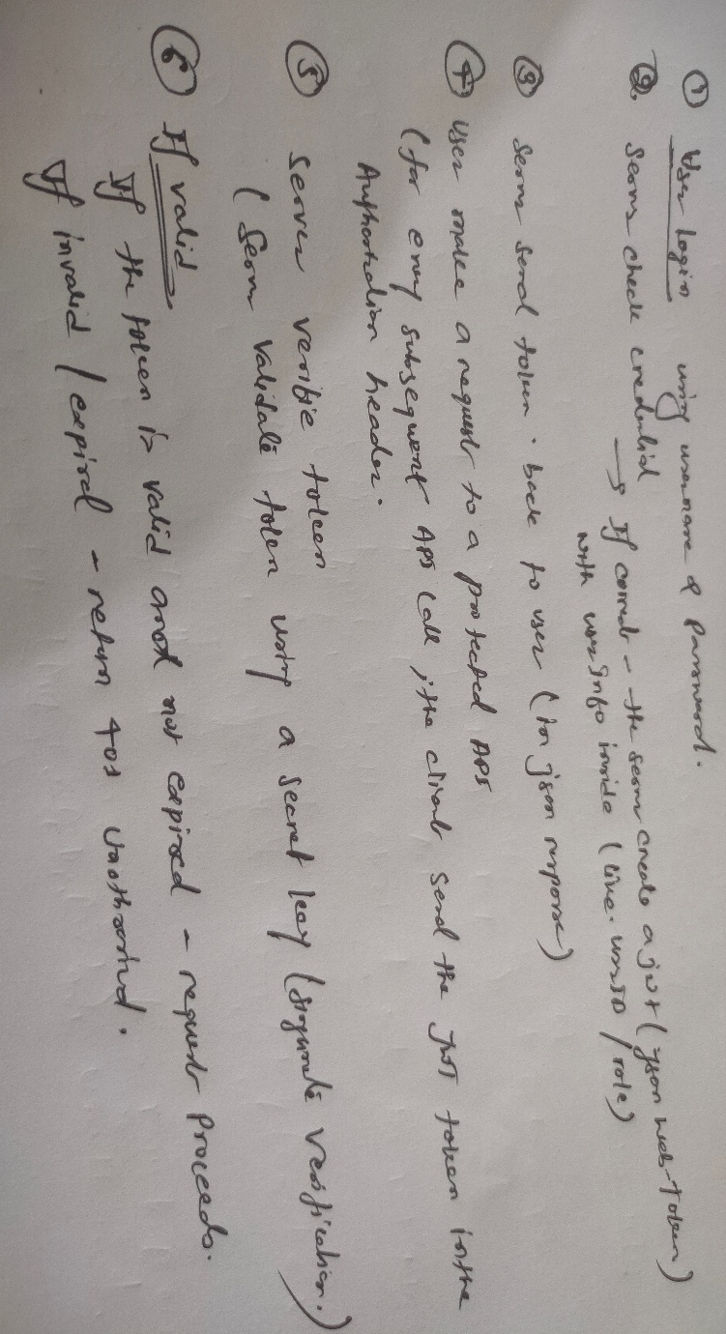sss
1️⃣ What is JWT and why do we use it instead of Session-based Authentication?
Answer:
- JWT (JSON Web Token) is a compact, URL-safe token used for securely transmitting information between parties.
- In session-based authentication, the server stores session data, leading to scalability issues.
- JWT is stateless — the server doesn’t store user data; all user info is inside the token.
- Perfect for distributed / microservices systems.
Example:
When you log into Netflix, you don’t want the server to store your login data in memory for every request — JWT allows you to carry the authentication info in your request itself.

2️⃣ Can you explain the flow of JWT Authentication in Spring Boot?
Answer:
- User logs in with username & password → sent to /login endpoint.
- Spring Boot verifies credentials using AuthenticationManager.
- If valid, server generates JWT token and sends it back to the client.
- For every subsequent API call, the client sends the JWT token in the Authorization: Bearer <token> header.
- The server validates token using a secret key (signature verification).
- If valid → request proceeds; if expired/invalid → 401 Unauthorized.
Real-Life Example:
Like a movie ticket — you buy it once, and then show it each time to enter. The cinema doesn’t remember you, but the ticket proves you’re allowed.

3️⃣ What is the JSON Web Token structure?
In its compact form, JSON Web Tokens consist of three parts separated by dots (.), which are:
- Header
- Payload
- Signature
Therefore, a JWT typically looks like the following:
xxxxx. yyyyy. zzzzz

4️⃣ Where should I save a JWT token?
1. Local Storage
2. Session Storage
3. HTTP-only Cookies (Most secure for web apps)
Best practice:
- For browser apps → use HTTP-only cookies with Secure + SameSite=Strict.
- For mobile/native apps → store securely in Keychain (iOS) or Keystore (Android).

✅9. Username & Password Authentication in Spring Security
Spring Security is like a security guard for your app, checking who you are, verifying your credentials, and authorizing you access if everything matches.

Step-by-Step in Spring Boot
1. Add Dependencies
In pom.xml (Maven):xml
<dependency>
<groupId>org.springframework. boot. boot</groupId>
<artifactId>spring-boot-starter-security</artifactId>
</dependency>
<dependency>
<groupId>org.springframework. boot. boot</groupId>
<artifactId>spring-boot-starter-web</artifactId>
</dependency>
2. Create a User (for testing)
In Spring Security 6+, you can create an in-memory user like this:
java
@Configuration
@EnableWebSecurity
public class SecurityConfig {

@Bean
public UserDetailsService userDetailsService () {
UserDetails user = User.withUsername("john")
. password("{noop}password123") // {noop} = no password encoding (for demo only)
. roles("USER")
. build ();
return new InMemoryUserDetailsManager(user);
}

@Bean
public SecurityFilterChain securityFilterChain (HttpSecurity http) throws Exception {
return http
. authorizeHttpRequests (auth -> auth
. anyRequest (). authenticated ()
)
.formLogin(withDefaults ()) // shows default login form
. build ();
}
}

3. Run & Test
- Start your Spring Boot app
- Open http://localhost:8080 → You’ll see a Spring Security login page
- Enter:
  - Username: john
  - Password: password123
- If correct → You get in. If wrong → Error.

1️⃣ How does Spring Security handle username and password authentication internally?
What they expect:
- Explain the flow — request → filter → authentication manager → provider → user details service → password encoder → authentication success/failure.
- Mention key classes like UsernamePasswordAuthenticationFilter, AuthenticationManager, UserDetailsService, and PasswordEncoder.
📌 Pro Tip:
Use a real-life analogy like — Security guard at an office checks ID (username) and passcode (password) before allowing entry.

2️⃣ What is UserDetailsService and why do we need it?
What they expect:
- It's an interface used by Spring Security to load user-specific data (username, password, roles) from a DB or other source.
- Custom implementation allows fetching user credentials from a database instead of hardcoding.
📌 Pro Tip:
Say: Think of UserDetailsService as a "database clerk" who retrieves the employee details for the security guard to verify.

3️⃣ Why do we use PasswordEncoder in Spring Security?
What they expect:
- Passwords should never be stored in plain text.
- PasswordEncoder (e.g., BCryptPasswordEncoder) hashes and verifies passwords securely.
📌 Pro Tip:
Explain with — Just like a locker’s key is cut in a unique shape (hash), we store the shape, not the original key.

✅10. CI/CD Pipeline
1. What is CI/CD?
- CI = Continuous Integration → Automatically testing and merging code changes from multiple developers into one main project.
- CD = Continuous Delivery/Deployment → Automatically delivering that tested code to the server or cloud where it runs for users.

2. Real-Life Easy Example
Think of CI/CD like an online food delivery app (like Zomato/Swiggy):
- You (Developer) = Chef preparing food (writing code).
- Kitchen Quality Check (CI) = Every time you make food, a quality inspector checks if it’s fresh and correct (tests your code automatically).
- Delivery Boy (CD) = Once quality is good, the delivery guy takes it to the customer’s home (deploys code to server).
If the food fails the quality check (tests fail), the delivery guy never leaves — just like code won’t be deployed if it has bugs.

3. Step-by-Step CI/CD Process
1️⃣ Developer writes code → pushes it to GitHub/GitLab/Bitbucket.
2️⃣ CI Tool runs tests (Jenkins, GitHub Actions, GitLab CI).
3️⃣ If all tests pass → code is merged into the main branch.
4️⃣ CD step automatically deploys the latest version to the server/cloud.
5️⃣ Users see changes instantly without manual installation.

4. Tools used in CI/CD
- CI Tools → Jenkins, GitHub Actions, GitLab CI, CircleCI
- Deployment Platforms → AWS, Azure, GCP, Heroku, Kubernetes

📢 Super Short Memory Line:
"CI checks the food, CD delivers it to the customer."

1️⃣ What is the difference between Continuous Integration, Continuous Delivery, and Continuous Deployment?
Why it’s asked: To check if you understand the core CI/CD concepts.
Example Answer (Easy):
- CI (Continuous Integration): Developers frequently merge their code into the main branch, and automated tests build & check it.
- CD (Continuous Delivery): After CI, the code is automatically packaged and ready for deployment, but deployment is still manual.
- CD (Continuous Deployment): Fully automated — code changes go straight to production after tests pass.

2️⃣ What are the common tools used in CI/CD pipelines?
Why it’s asked: To check if you know the industry tools.
Example Answer:
- CI Tools: Jenkins, GitHub Actions, GitLab CI, CircleCI
- CD Tools: ArgoCD, Spinnaker, AWS CodePipeline
- Container/Deployment: Docker, Kubernetes

Level 3 📚
✅11.THREAD
1️⃣Thread States in Java
Java threads can be in 6 main states (as per Thread. State enum):
- NEW – Thread is created but not started yet.
- RUNNABLE – Thread is ready to run or running.
- BLOCKED – Thread is waiting to enter a synchronized block/method.
- WAITING – Thread is waiting indefinitely for another thread to signal it.
- TIMED_WAITING – Thread is waiting for a specific time.
- TERMINATED – Thread has finished execution.

Thread Transitions
- NEW → RUNNABLE → when you call start ()
- RUNNABLE → BLOCKED → when thread tries to access a locked resource
- RUNNABLE → WAITING / TIMED_WAITING → when wait () / sleep () / join () is called
- RUNNABLE → TERMINATED → when thread completes run () method

2️⃣Synchronized method vs synchronized block
1. Synchronized Method
- Lock on the whole method → Once one thread enters the method, other threads must wait until it’s done.
- Lock is on the object (this) for instance methods, or on the class for static methods.
Example:
Imagine a bathroom in your house.
- You put the lock on the whole bathroom — only one person can use it at a time, even if they just need the sink.
- Others must wait outside until it’s free.

2. Synchronized Block
- Lock only part of the code → Only the critical section is locked, other code can still run in parallel.
- You can choose which object to lock.
Example:
Same bathroom, but you put a lock only on the shower area 🚿.
- One person can take a shower while another can use the sink at the same time.
- Faster, because only the sensitive area is locked.

3️⃣Difference between submit () and execute () in ExecutorService
Feature | execute () | submit ()
Return Type | void (no result back) | Future (can get result later)
Exception Handling | Exceptions are thrown immediately and may terminate the thread | Exceptions are captured inside the Future, you can handle them later
Use Case | When you just want to run a task, no need for result | When you need to get result or check status of the task

Real-Life Example
Imagine you have a restaurant and workers are threads.
- execute () → You tell the waiter:
"Please serve water to Table 5" —
You don’t need to know when he finishes, you just trust he’ll do it.
- submit () → You tell the chef:
"Make a pizza and let me know when it’s ready" —
You get a token (like Future) to check later: "Is my pizza ready?", or to get the result: "Here’s your pizza!".

execute () → Runs task, no result.
submit () → Runs task, gives you a Future to get result later.
Example: execute () is like “Deliver this letter”, submit () is like “Deliver and send me a delivery receipt”.

4️⃣CompletableFuture
1. What is CompletableFuture?
CompletableFuture is like a smart Future in Java that not only runs tasks in the background but also lets you chain tasks, handle results, and deal with errors without blocking your main thread.
It’s part of Java 8+ (in java. util. concurrent) and is used for asynchronous programming.

2. Problem with Traditional Future
With Future:
- You submit a task and get a Future object.
- To get the result, you call. get ().
- But. get () blocks the main thread until the result is ready (you’re stuck waiting).
- No easy way to chain multiple async tasks.
- No built-in exception handling for async tasks.

3. How CompletableFuture is Better
- Non-blocking: You can run code after the result is ready without blocking.
- Chaining: You can link multiple async tasks together.
- Error handling: Built-in support to handle failures.
- Combining tasks: Run tasks in parallel and combine their results.
- Manually complete: You can even set the result yourself.

4. Real-time Example
Scenario: Ordering Pizza
🍕 Traditional Future (Old way)
- You order a pizza and sit at the shop doing nothing until it’s ready (. get () blocks).
- Only after you get the pizza, you go home and start eating.
🍕 CompletableFuture (Smart way)
- You order a pizza.
- While the shop makes it, you go shopping 🛒.
- The shop calls you when pizza is ready, and you directly eat it (no waiting at the shop).
- You can also say: “After pizza is ready, also bring me a cold drink” → That’s chaining tasks.

In short:
- Future → Blocks until result comes, no chaining.
- CompletableFuture → non-blocking, chainable, better for async work.

5️⃣Difference between shutdown () and shutdownNow () in ExecutorService
- shutdown () → Stops accepting new tasks, lets current tasks finish.
- shutdownNow () → Tries to stop running tasks immediately.
- Example: shutdown () is like closing a shop after current customers finish, shutdownNow () is like kicking customers out instantly.

6️⃣What is Thread Safety?
- Code is thread-safe if multiple threads can use it without corrupting data.
- Example: A vending machine that handles multiple customers without giving wrong change.

7️⃣Difference between Parallel Stream and Sequential Stream in Java 8
- Sequential Stream → Processes elements one by one.
- Parallel Stream → Splits data and processes in multiple threads.
- Example:
  - Sequential: One chef cooking dishes one after another.
  - Parallel: Multiple chefs cooking different dishes at the same time.

✅12. How to Make a Spring Boot Application Faster
10 Performance Tuning Tips for Spring Boot
1️⃣ Optimize Application Startup Time
Spring Boot applications can take time to start due to eager bean initialization.
📢 Enable Lazy Initialization
Lazy initialization delays the creation of beans until they are needed, improving startup time.
Add to application. properties:
spring. main.lazy-initialization=true

2️⃣ Reduce Unnecessary Auto-Configurations
Spring Boot loads all auto-configurations by default. Disabling unnecessary ones speeds up startup and improves memory usage.
📢 Exclude Unused Auto-Configurations
Disable unused configurations in application. properties:
spring.autoconfigure.exclude=org.springframework.boot.autoconfigure.jdbc.DataSourceAutoConfiguration

3️⃣ Optimize JVM Memory Settings
Tuning JVM settings can prevent memory leaks and improve performance.
📢 Set Optimal Heap Size
Use JVM flags to optimize heap memory:
java -Xms512m -Xmx1024m -jar myapp.jar
Enable G1 Garbage Collector:
java -XX:+UseG1GC -jar myapp.jar
For ultra-low latency apps, use ZGC:
java -XX:+UseZGC -jar myapp.jar

4️⃣ Optimize Database Performance
📢 Use Connection Pooling
Database connections are expensive. Use HikariCP for efficient pooling.
Configure HikariCP in application. properties:
spring. datasource. hikari. maximum-pool-size=20
spring.datasource.hikari.maximum-idle=5
spring.datasource.hikari.idle-timeout=30000
spring.datasource.hikari.max-lifetime=60000
📢 Use Indexing for Faster Queries
Ensure indexes are applied to frequently queried columns.
Example: Create Index on MySQL Database Table
CREATE INDEX idx_product_name ON product (name);

5️⃣ Use Caching to Reduce Database Calls
Caching stores frequently accessed data in memory, reducing database calls and improving response times.
📢 Enable Caching in Spring Boot
Add dependency in pom.xml:
<dependency>
<groupId>org.springframework. boot</groupId>
<artifactId>spring-boot-starter-cache</artifactId>
</dependency>
Enable caching in the main class:
@SpringBootApplication
@EnableCaching
public class MyApplication { }
Use @Cacheable to cache results:
@Cacheable("products")
public List<Product> getAllProducts () {
return productRepository.findAll();
}

6️⃣ Optimize REST API Performance
Spring Boot REST APIs should be optimized for speed and low latency.
Enable GZIP Compression
Add to application. properties:
server. compression. enabled=true
server. compression. mime-types=text/html, text/xml, text/plain, application/json
📢 This reduces response size, improving API performance.

7️⃣ Use Asynchronous Processing for Heavy Tasks
For heavy computations or long-running tasks, use @Async to execute them asynchronously.
Enable Async Processing:
@EnableAsync
@SpringBootApplication
public class MyApplication { }
Execute tasks asynchronously:
@Async
public CompletableFuture<String> processHeavyTask () {
return CompletableFuture.supplyAsync(() -> "Task Completed");
}
📢 This prevents API calls from blocking the main thread.
8️⃣ Use Virtual Threads for Better Concurrency
Spring Boot 3 supports Virtual Threads (JEP 425) to improve multi-threading performance.
Enable Virtual Threads for Task Execution:
@Bean
Executor taskExecutor () {
return Executors.newVirtualThreadPerTaskExecutor();
}
📢 Virtual Threads improve scalability for high-load applications.
9️⃣ Optimize Logging for Faster Processing
Logging can slow down an application. Use asynchronous logging to improve performance.
Use Async Logging with Logback
Update logback.xml:
<configuration>
<appender name="ASYNC" class="ch.qos. logback. classic. AsyncAppender">
<appender-ref ref="FILE"/>
</appender>
</configuration>
📢 This prevents logging from slowing down request processing.

🔟 Monitor Application Performance with Actuator
Spring Boot Actuator provides built-in metrics and health monitoring.
Enable Actuator for Monitoring
Add Actuator dependency:
<dependency>
<groupId>org.springframework. boot</groupId>
<artifactId>spring-boot-starter-actuator</artifactId>
</dependency>
Expose monitoring endpoints:
management.endpoints.web. exposure. include=health, info, metrics
📢 Check app health using /actuator/health.

✅13. Multiple Databases in Spring Boot
1. Concept (Easy Way)
In a Spring Boot application, sometimes you need to work with more than one database.
Example:
- DB1 → Stores Customer Information.
- DB2 → Stores Orders Information.
It’s like running two different bank accounts:
- One account for salary 💰.
- Another account for investments 📈.
You use different passbooks (configs) but in one life (same app).

2. How It Works
In Spring Boot:
- You create two different datasource configurations (one for each DB).
- You create separate repositories for each DB.
- Spring knows which repository talks to which database.

3. Steps
Example: MySQL for customers, PostgreSQL for orders.

application. properties
# DB1 - MySQL
spring.datasource.customer.url=jdbc: mysql://localhost:3306/customerdb
spring. datasource. customer. username=root
spring. datasource. customer. password=root

# DB2 - PostgreSQL
spring.datasource.order.url=jdbc: postgresql://localhost:5432/orderdb
spring. datasource. order. username=postgres
spring. datasource. order. password=postgres

DB1 Config (MySQL)
java
@Configuration
@EnableJpaRepositories (
basePackages = "com.example. repo. customer",
entityManagerFactoryRef = "customerEntityManager",
transactionManagerRef = "customerTransactionManager"
)
public class CustomerDbConfig {
@Bean
@ConfigurationProperties (prefix = "spring. datasource. customer")
public DataSource customerDataSource () {
return DataSourceBuilder.create(). build ();
}
}

DB2 Config (PostgreSQL)
java
@Configuration
@EnableJpaRepositories (
basePackages = "com.example. repo. order",
entityManagerFactoryRef = "orderEntityManager",
transactionManagerRef = "orderTransactionManager"
)
public class OrderDbConfig {
@Bean
@ConfigurationProperties (prefix = "spring. datasource. order")
public DataSource orderDataSource () {
return DataSourceBuilder.create(). build ();
}
}

